**Instiute Of Fine Arts**

**PROJECT GROUP MEMBER**

|  |  |
| --- | --- |
| ***Students Id*** | ***Students Name*** |
| *Student1434943* | *Muhammad Mohtashim* |
| *Student1430194* | Hafiz Abdur Rafay |
| *Student1435114* | *Syed Muhammad Ibad* |
| *Student1435107* | *Shuja Abbas* |
| *Student1452991* | *Muhammad Azam* |
| *Student1431524* | Ameer Hamza |

**CURRICULUM BATCH**

**7062 2302B1**

**FACULTY**

**SIR HARIS NASEER**

**CO-ORDINATOR**

**MISS MAHA HAIDER**

**CERTIFICATE**

This is to certify that the dissertation **“Institute of Fine Arts”**

is **Muhammad Mohtashim Student 1434943,**

**Hafiz Abdul Rafay Student 1430194,**

**Syed Muhammad Ibad Student 1435114,**

**Shuja Abbas Student 1435107 ,**

**Muhammad Azam Student 1452991,**

**Ameer Hamza Student 1431524,**

in their partial fulfilment of the requirement of the

award of the Aptech Computer Certified.

**ADMIN SCREENSHORTS**

**LOGIN**

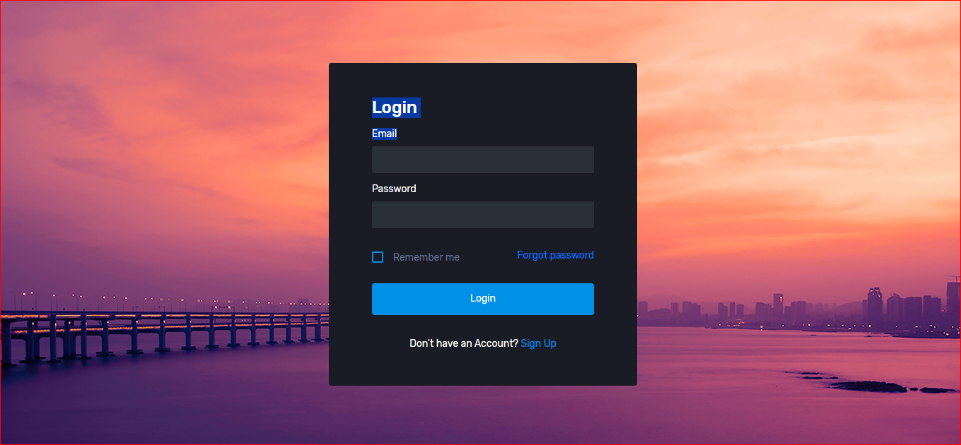

**SIGNUP**



**ADD MANAGER**

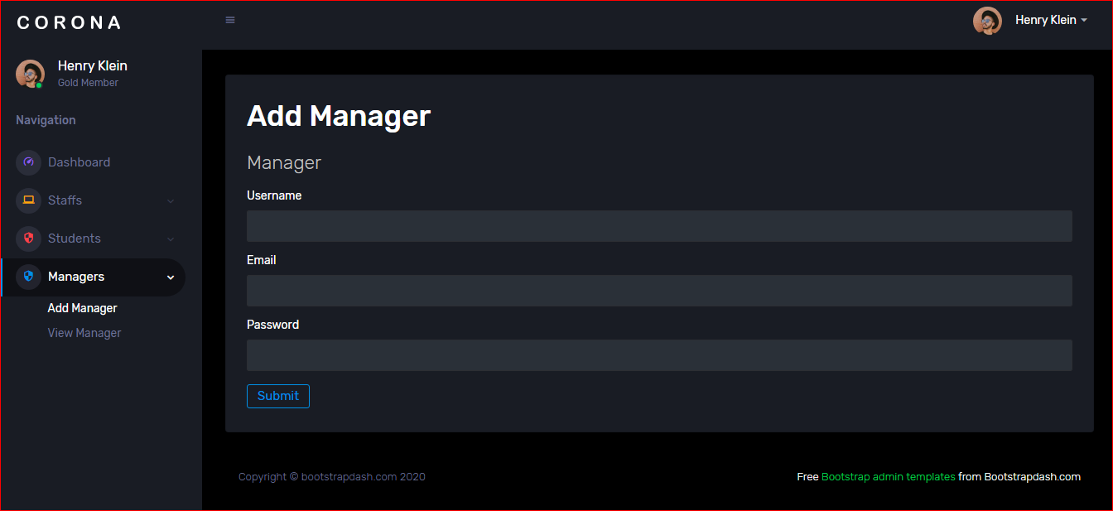**ADD MANAGER**

**VIEW MANAGER**

**ADD MANAGER**

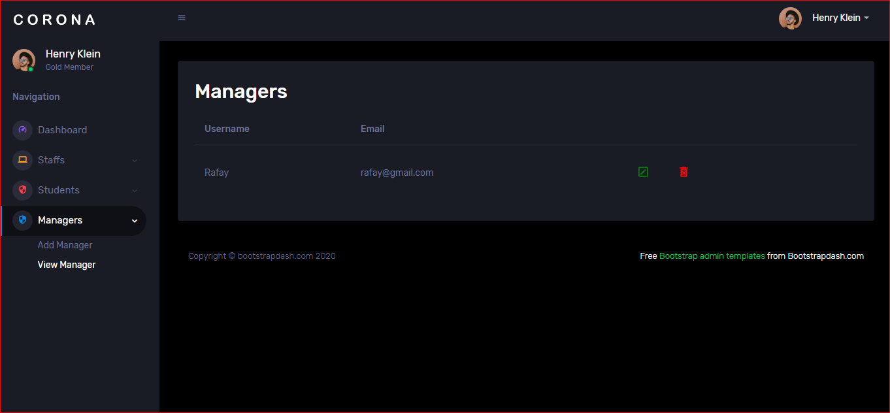

**ADD STAFF**

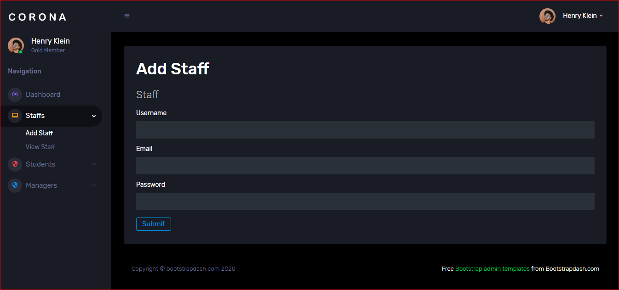

**VIEW STAFF**

**VIEW STAFF**

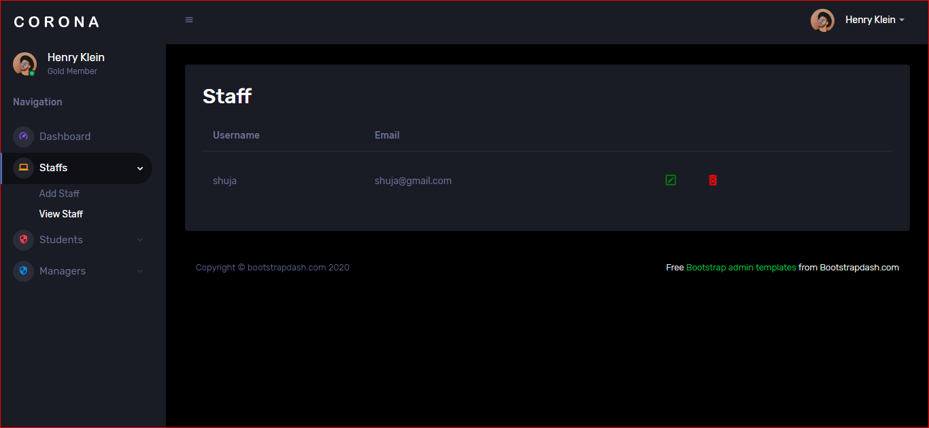

**ADD COMPETITION**

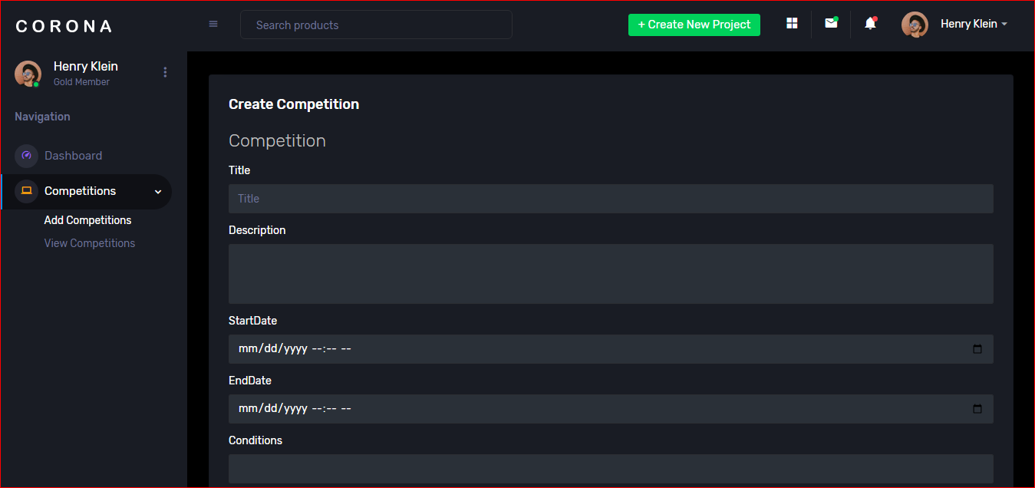

**VIEW COMPETITION**

**VIEW COMPETITION**

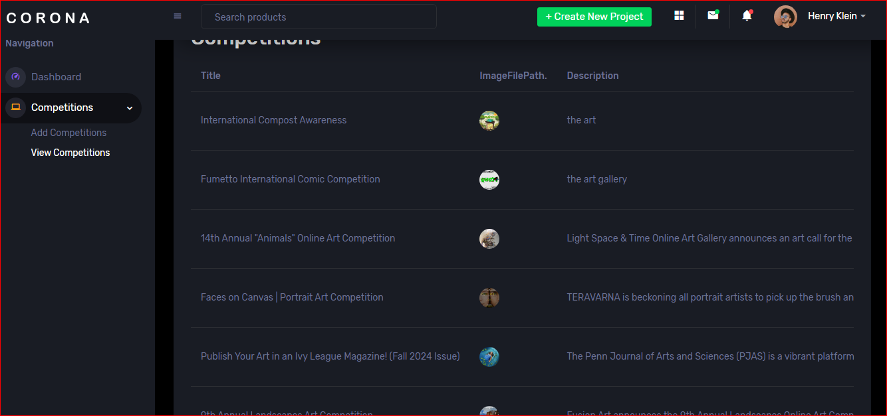

**WEBSITE SCREENSHORTS**

**HOME**



**ABOUT**



**CONTACT**

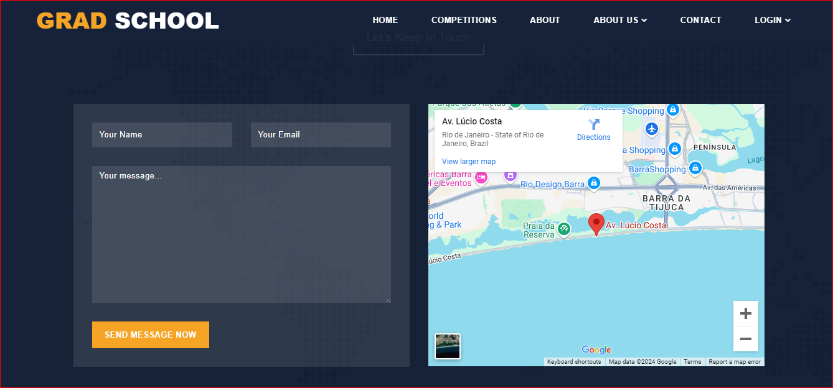

**LATEST COMPETITION**

